EduAgent: A Multi-Agent AI Educational Ecosystem with Inter-Agent Collaboration and Adaptive Learning
Abhyudit Agrawal¹, Arpit Dash¹, Santoshi Quenim¹, Muskan Dosani¹, Soni Sweta²
¹Department of Computer Engineering, Mukesh Patel School of Technology Management & Engineering, SVKM'S NMIMS, Mumbai, India
²Assistant Professor, Department of Computer Engineering, Mukesh Patel School of Technology Management & Engineering, SVKM'S NMIMS, Mumbai, India
¹{abhyudit.agrawal23, arpit.dash60, santoshi.quenim20, muskan.dosani03}@nmims.in, ²soni.sweta@nmims.edu
(Corresponding author: Abhyudit Agrawal, e-mail: abhyudit.agrawal23@nmims.in)

Abstract—The rapid advancement of large language models (LLMs) has opened transformative possibilities for AI-enhanced education. Yet most existing solutions rely on a monolithic, single-agent chatbot model that cannot distinguish between different educational tasks such as concept explanation, exam preparation, self-assessment, progress tracking, and academic-writing evaluation. Users are forced to switch context between disconnected tools, losing both the continuity of their learning process and the pedagogical coherence of a unified educational environment. This paper introduces EduAgent, a full-stack multi-agent AI educational platform offering six specialised agents for students — Concept QA, Exam Predictor, Weak-Point Tracker, Protégé (Feynman technique), Oral Viva, and Essay Critique — all sharing a common knowledge layer consisting of a RAG vector store, a concept dependency graph, and an SM-2 spaced-repetition per-student mastery state. Unlike single-chatbot solutions, EduAgent employs a LangGraph-based orchestrator that classifies student intent from natural-language queries and routes each message to the optimal specialised agent. The platform introduces an inter-agent collaboration mechanism in which agents consult one another's data — weak-point awareness, concept mastery levels, overdue review schedules, and prerequisite gap analysis — to deliver contextually enriched, pedagogically coherent responses. Key technical contributions include SM-2 spaced repetition with auto-generated flashcards; an AI-powered personalised study planner; voice-enabled oral-viva simulation; multimodal diagram understanding via Google Gemini; WebSocket-based collaborative study rooms with a live shared whiteboard and AI-moderated peer debate; a no-code custom agent builder for professors; class-level analytics; and automated concept-dependency detection from uploaded course material. Beyond these, EduAgent introduces four novel learning-intelligence contributions: (i) a Bayesian Knowledge Tracing (BKT) engine, with parameters fitted per student via expectation–maximisation once sufficient interaction history exists, that estimates the latent probability that a skill is truly learned; (ii) a predictive forgetting model, based on the Ebbinghaus retention curve, that forecasts the day on which each concept will be forgotten, drives a learning-outcome predictor for an upcoming exam date, and triggers proactive review; (iii) a Multi-Agent Debate and Consensus mode, extended with an AI-moderated peer-debate variant in which two students argue a question, in which a Proponent and a Skeptic argue a question and a neutral Judge synthesises a balanced answer; and (iv) a Learning Genome — a per-student cognitive fingerprint (pace, preferred modality, peak study hour, persistence, misconception signatures, and peer-collaboration signals) to which every agent adapts — together with a Knowledge Frontier that operationalises Vygotsky's Zone of Proximal Development to recommend the single best next concept to study. To reduce hallucination risk, every fact-answering agent's prompt now carries an explicit grounding instruction and a lightweight post-hoc confidence check that flags answers weakly supported by retrieved course material. The system is deployed as a five-service Docker Compose stack (PostgreSQL 16, Qdrant, Redis 7, FastAPI, Next.js 16) validated by more than 130 automated tests, and its adaptive pipeline is additionally validated end-to-end against a simulated 45-day usage trace showing per-concept mastery, forgetting, and readiness scores converging to internally consistent, explainable values. A structured user-study protocol is presented to evaluate the platform's effectiveness in improving learning outcomes through adaptive, multi-agent interaction.
Index Terms—Multi-Agent Systems, Educational AI, Retrieval-Augmented Generation, Spaced Repetition, LangGraph, Adaptive Learning, Inter-Agent Collaboration, Large Language Models, Concept Graph, Bayesian Knowledge Tracing, Predictive Forgetting, Zone of Proximal Development, Multi-Agent Debate, Hallucination Mitigation.
I. INTRODUCTION
Large language models such as GPT-4 [9], Gemini [10], and Claude have opened transformative possibilities for AI-enhanced education. These systems are built on the Transformer architecture [18] and owe much of their generalisation ability to large-scale pre-training strategies such as masked language modelling [19] and few-shot, in-context learning [20], which together give a single model the capacity to understand, reason about, and generate natural language well enough to support intelligent tutoring systems that go far beyond earlier rule-based approaches. Yet most existing educational AI systems use a one-agent chatbot architecture — a monolithic conversational interface that attempts to handle every educational task through a single model endpoint and a common system prompt. Such an architecture cannot easily distinguish the different cognitive and pedagogical demands of tasks as varied as concept explanation, exam preparation, self-evaluation, metacognitive assessment, and academic writing review.
The shortcomings of a single-agent educational chatbot are numerous. First, one system prompt cannot simultaneously support Socratic questioning for concept explanation and the rubric-based evaluation needed for essay assessment. Second, without persistent per-student state, the system cannot tailor feedback to a student's proficiency level or identify the prerequisite gaps that are blocking understanding. Third, students must switch between disconnected applications — flashcards, practice questions, and progress trackers — losing continuity in the process. Fourth, a single conversational endpoint has no principled way to signal when it is extrapolating beyond the material it was actually given, so ungrounded answers are presented with the same confident tone as grounded ones — a hallucination-risk problem that grows more acute, not less, as a tutoring system is trusted with more of a student's study time.
EduAgent addresses this problem through a multi-agent architecture in which six specialised AI agents operate over a shared data layer. Each agent has its own system prompt, assessment rubric, and interaction pattern tailored to a specific educational task: Concept QA resolves conceptual doubts with prerequisite awareness; Exam Predictor generates mastery-based practice questions; Weak-Point Tracker schedules review using SM-2 principles and prioritises study; Protégé conducts assessment through the Feynman technique; Oral Viva performs adaptive-difficulty oral assessment with voice support; and Essay Critique evaluates academic writing with source fact-checking.
A LangGraph-based orchestrator classifies each student query into one of seven intent categories — conceptual doubt, exam prep, weak points, teach-me, viva, critique, or general — and routes the message to the corresponding specialised agent, so that students never need to explicitly select an agent mode. An inexpensive rule-based fast path resolves unambiguous phrasings (e.g. “quiz me on X”, “let me teach you X”) without an LLM round-trip; only genuinely ambiguous messages reach the LLM classifier, reducing average routing latency.
A central innovation of EduAgent is its inter-agent collaboration mechanism. Before an agent generates its response, the streaming platform enriches its context with information drawn from other agents' domains. Specifically, the Concept QA agent is alerted to prerequisite gaps identified by the Weak-Point Tracker's mastery assessment; the Exam Predictor skips concepts the student state service has identified as already mastered; and the Protégé and Viva agents are informed of weak points to probe within their respective sessions. This cross-agent context is injected directly into the LLM prompt.
The contributions of this paper are as follows: (1) a multi-agent educational architecture with inter-agent collaboration, in which agents draw on one another's mastery statistics, weak-point analyses, and review schedules through prompt-level context injection; (2) an implementation of the SM-2 spaced-repetition algorithm driven by auto-generated flashcards extracted from educational conversations by the LLM; (3) a personalised, AI-generated daily revision planner that accounts for mastery statistics, weak topics, missed reviews, and exam dates; (4) oral-exam simulation through voice interaction via the Web Speech API, requiring no additional speech-processing service; (5) multimodal understanding of diagrams, flowcharts, and handwritten notes via Google Gemini's vision capabilities; (6) WebSocket-based collaborative study rooms with a shared AI assistant, a live collaborative whiteboard, and an AI-moderated peer-debate mode, all available to every room participant; (7) a custom agent builder that lets professors create domain-specific assessment agents with custom system prompts and rubrics, without writing code; (8) class-level analytics with agent-performance monitoring, weak-concept identification, and automated PDF progress-report export; (9) a Bayesian Knowledge Tracing engine, with parameters fitted per student via expectation–maximisation once sufficient history exists, coupled with an Ebbinghaus-based predictive forgetting model and a learning-outcome predictor for proactive, mastery-aware intervention; (10) a Multi-Agent Debate and Consensus mode that surfaces multiple perspectives on ambiguous questions through adversarial reasoning and neutral synthesis; (11) a Learning Genome cognitive fingerprint, extended with peer-collaboration signals from study rooms and shared material annotations, injected into every agent for continuous personalisation; (12) a Knowledge Frontier that operationalises the Zone of Proximal Development to provide a next-best-concept learning guide; (13) a provider-agnostic LLM abstraction layer (Gemini, OpenAI, or Anthropic) that removes single-vendor lock-in; and (14) explicit grounding instructions and a post-hoc confidence check applied to every fact-answering agent to reduce hallucination risk, together with an illustrative, fully reproducible simulated-usage validation trace demonstrating that the adaptive pipeline converges to internally consistent mastery, forgetting, and readiness estimates.
The remainder of this paper is organised as follows. Section II surveys related work in educational AI, multi-agent systems, and spaced repetition. Section III describes the system architecture, including all five services and their data flows. Section IV details the design of each specialised agent and the orchestrator. Section V covers the adaptive learning engine, including SM-2 integration and study planning. Section VI presents the advanced learning-intelligence engines: Bayesian Knowledge Tracing (with per-student parameter fitting), predictive forgetting and learning-outcome prediction, multi-agent debate, the Learning Genome, and the Knowledge Frontier. Section VII describes collaboration and real-time features, including the collaborative whiteboard, peer-debate mode, and material annotation. Section VIII covers analytics and observability. Section IX presents the custom agent builder. Section X details implementation specifics, including the multi-provider LLM abstraction and hallucination-mitigation mechanism. Section XI presents the evaluation methodology, preliminary results, and an illustrative simulated-usage validation trace. Section XII discusses findings, limitations, and future work, and Section XIII concludes the paper.
II. RELATED WORK
A. Intelligent Tutoring Systems
Intelligent tutoring systems (ITS) have a history spanning more than five decades. Early systems such as SCHOLAR [11] and WHY [12] used semantic networks and Socratic dialogue to teach geography and meteorology, respectively. The Cognitive Tutor [3], developed at Carnegie Mellon University as part of the adaptive math-instruction system MATHia, uses cognitive modelling grounded in ACT-R theory. While effective for personalised instruction, this generation of systems suffered from inflexible domain modelling and a lack of natural-language interfaces.
The emergence of LLMs has fundamentally changed the landscape of educational AI. Khan Academy's Khanmigo [1] provides a single-agent AI tutor, powered by GPT-4, that can explain concepts, generate practice problems, and give writing feedback across subjects; however, Khanmigo uses one conversational agent that does not differentiate between educational activities or maintain per-concept mastery state. Duolingo Max [2] uses GPT-4 to power role-play conversations and mistake explanations for language learning, demonstrating the value of specialised AI interactions while remaining domain-specific to language acquisition.
B. Multi-Agent Systems in AI
Multi-agent systems (MAS) coordinate multiple autonomous agents to solve tasks that exceed the capability of any single agent. In software engineering, MetaGPT [4] assigns distinct roles — product manager, architect, engineer — to LLM agents that collaborate through structured communication protocols, and AutoGen [5] provides a framework for multi-agent conversations in which agents can be customised with different capabilities and interaction patterns. CAMEL [13] explores communicative agents through role-play, while Generative Agents [14] simulate believable human behaviour through memory-augmented LLM agents.
The application of multi-agent architectures to education, however, remains limited. Most educational MAS research has focused on simulation environments or theoretical frameworks rather than production-ready platforms with integrated adaptive-learning algorithms. EduAgent bridges this gap by implementing a practical multi-agent educational system in which each agent serves a distinct pedagogical function.
C. Spaced Repetition and Memory Models
The SM-2 algorithm, developed by Wozniak [6] and implemented in the SuperMemo system, is among the most widely adopted spaced-repetition algorithms. It schedules review sessions using an easiness factor that adapts to the learner's demonstrated retention quality, and research has shown that it yields markedly better retention than massed practice. Anki, an open-source flashcard program popular in medicine and language learning, implements a variant of SM-2. All existing spaced-repetition programs, however, are standalone applications that sit outside the learning process itself and require the user to manually author flashcards after each study session, missing the opportunity to automate knowledge extraction.
EduAgent embeds SM-2 directly into the learning process: the Concept QA agent administers comprehension checks that update concept-mastery schedules, and flashcards are generated automatically from the educational conversation itself.
D. Retrieval-Augmented Generation
Retrieval-Augmented Generation (RAG) [7] addresses the problem of LLM hallucination by grounding model output in facts retrieved from an external database, combining a retrieval component with a generative component so that responses are anchored to retrieved evidence. In education, RAG allows AI tutors to give accurate, course-specific explanations instead of relying solely on an LLM's parametric knowledge. RAG alone, however, does not guarantee that a model actually uses the retrieved material faithfully rather than defaulting back to parametric knowledge when the retrieved context is sparse or only tangentially relevant — a gap EduAgent addresses directly (Section X-E) with explicit grounding instructions and a retrieval-confidence check on the generated response.
Vector databases such as Qdrant, Pinecone, and ChromaDB support RAG pipelines. EduAgent uses Qdrant with sentence-transformer embeddings (all-MiniLM-L6-v2, producing 384-dimensional vectors) to index course material chunked from uploaded PDFs, enabling per-subject semantic retrieval.
E. LLM Orchestration Frameworks
LangChain [15] offers a composable framework for building LLM applications through chains, agents, and memory. LangGraph [8] extends LangChain with a stateful, graph-based workflow in which agent interactions are modelled as nodes and edges of a directed graph — an approach well suited to multi-agent orchestration, where the invocation of different agents is conditional on input classification and state is passed between processing stages.
EduAgent distinguishes itself from prior work by combining intent-classified multi-agent routing, inter-agent cooperation through shared state, SM-2 spaced repetition, RAG-grounded responses, real-time collaboration, and comprehensive analytics in a single, ready-to-use full-stack system. Table I summarises this comparison against existing approaches.
TABLE I. COMPARISON WITH EXISTING SYSTEMS
System | Multi-Agent | Spaced Rep. | RAG | BKT / Forgetting | Debate | ZPD
Khanmigo [1] | No | No | Partial | No | No | No
Duolingo Max [2] | No | Yes | No | No | No | No
MATHia [3] | No | Yes (BKT) | No | Partial | No | No
ChatGPT (generic) | No | No | No | No | No | No
EduAgent (ours) | Yes (6 + debate) | Yes (SM-2 + BKT) | Yes | Yes (per-student) | Yes (AI + peer) | Yes
III. SYSTEM ARCHITECTURE
EduAgent uses a five-service microservice architecture, deployed with Docker Compose, in which each service performs a distinct role within the educational pipeline. Fig. 1 depicts the overall architecture, spanning the client, application, data-and-intelligence, and external AI-service layers described in the remainder of this section.
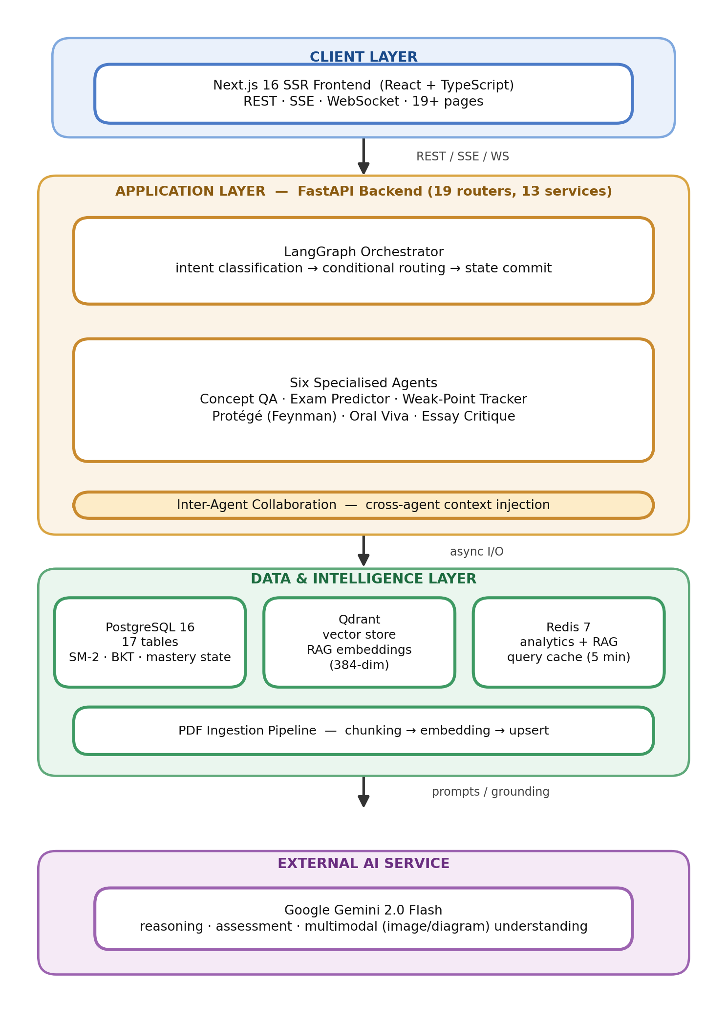
Fig. 1. EduAgent system architecture. The Next.js frontend communicates with the FastAPI backend over REST, SSE, and WebSocket; the LangGraph orchestrator routes each request to one of six specialised agents with inter-agent context injection; and the application layer reads and writes PostgreSQL, Qdrant, and Redis before grounding each response in Google Gemini (or an alternative provider via the LLM abstraction layer, Section X-E).
A. Frontend Service (Next.js 16)
The frontend is a server-side-rendered (SSR) React application built with Next.js 16, TypeScript, and the App Router architecture. The UI layer is styled with the utility-first TailwindCSS framework and composed from shadcn/ui components (built on Radix UI). Client-side state is managed with Zustand, chosen over Redux for its lighter, more predictable state containers, and concept-graph visualisation uses the React Flow library to render an interactive directed acyclic graph (DAG) of concept dependencies with mastery-coloured nodes.
Three channels connect the frontend to the backend: (1) REST APIs for CRUD operations on subjects, concepts, flashcards, study plans, and user profiles; (2) Server-Sent Events (SSE) for streaming agent responses token by token, keeping chat interaction fast and responsive; and (3) WebSockets for real-time collaborative study rooms, the shared whiteboard, and peer debate. Authentication is handled by NextAuth.js, which manages JWT tokens, session persistence, and credential-based login. The frontend comprises 19+ pages, including chat, dashboard, concept map, flashcards, study planner, learning-path timeline, study groups, profile, onboarding, and admin views.
B. Backend Service (FastAPI)
The backend is an asynchronous Python API server built with FastAPI, providing non-blocking I/O for database access, LLM calls, and vector-store queries through Python's asyncio ecosystem. It exposes 20 API routers organised by domain: authentication (login, registration, token refresh), chat (message submission, chat management, SSE streaming), subjects (CRUD, enrolment), concepts (CRUD, prerequisite management), dashboard (mastery summary, study priority, overdue reviews), flashcards (browsing, SM-2 review, automatic and manual generation), analytics (agent performance, class mastery, weak concepts, intent distribution), study plan (generation and listing), progress report (PDF generation), custom agents (CRUD), study rooms (creation, joining, listing), image chat (multimodal analysis), WebSocket (real-time messaging, whiteboard strokes, peer debate), knowledge tracing (BKT mastery probabilities, forgetting forecasts, observations, per-student parameter fitting, learning-outcome prediction), debate (multi-agent debate SSE streaming), learning genome (reading and refreshing the cognitive fingerprint), knowledge frontier (ZPD-based concept partitioning), and material annotations (collaborative notes on course material).
Database access uses SQLAlchemy 2.0 with the asynchronous PostgreSQL driver asyncpg, through type-safe mapped columns and async sessions. Schema migrations are managed by Alembic across six versioned migration files, and structlog provides machine-readable structured logging. On startup, the server performs health checks to verify the Gemini API key and connectivity to Redis and the database, and pre-warms the local sentence-embedding model so that a student's first RAG-grounded request is not the one paying its one-time load cost.
C. PostgreSQL 16 (Relational Database)
PostgreSQL 16 is the primary relational store for the application's persistent state, spanning 20 tables (Table III). The principal tables are: users (authentication information, roles, preferences); subjects (course metadata); concepts (topic nodes with chapter, difficulty_tier, and description); concept_prerequisites (edges of the prerequisite dependency graph); enrollments (student–subject associations); student_concepts (per-student concept state, including the SM-2 parameters confidence_score, easiness_factor, interval_days, attempts, correct_count, last_seen_at, and next_review_at, alongside the BKT/forgetting fields bkt_mastery, memory_stability, and predicted_forget_at); conversations (chat sessions tied to a subject); messages (chat messages with role and content); ingestion_jobs (tracking the status of uploaded-PDF processing); flashcards (front and back of each card with its own SM-2 schedule); agent_logs (per-invocation performance telemetry); learning_events (milestones rendered on the learning-path timeline); study_plans (AI-generated schedules stored as JSONB); custom_agents (professor-defined agents with system prompt and rubric as JSONB); study_rooms (room metadata); study_room_members (room membership with timestamps); learning_genomes (the per-student cognitive fingerprint described in Section VI-D, including the collaboration_score and peer_sessions_count fields introduced in Section VII); student_bkt_params (per-student, EM-fitted BKT parameters, Section VI-F); bkt_observations (the raw correct/incorrect observation log the EM fit is estimated from); and material_annotations (persisted, room-broadcast notes pinned to a page of course material, Section VII-F).
Referential integrity is enforced with foreign-key constraints — cascade deletion for owner/owned relationships and SET NULL for optional relationships. UUIDs are used as primary keys throughout to guarantee globally unique identifiers, and timestamps use timezone-aware DateTime fields with server-side defaults. The connection pool is configured with pool_size = 10 and max_overflow = 20.
D. Qdrant (Vector Database)
Qdrant stores the dense vector embeddings used for RAG over ingested course material. When a professor uploads a course PDF, the ingestion pipeline extracts its textual content, chunks it into semantically coherent sections of roughly 500 tokens with a 50-token overlap, computes embeddings with the all-MiniLM-L6-v2 sentence-transformer model (384-dimensional vectors), and upserts the resulting vectors into a subject-specific Qdrant collection. At query time, the student's message is embedded with the same model, and its top-k most relevant chunks (k ≈ 5) are supplied to the agent's prompt as grounding material.
Collections are partitioned by subject so that retrieval is confined to material within the relevant course and is not contaminated by content from other subjects; a collection is dropped when its subject is deleted, so a later subject re-using the same code cannot inherit orphaned vectors. Every stored point carries metadata — PDF file name, page number, chunk index, and associated concept IDs — for full traceability.
E. Redis 7 (Cache Layer)
Redis 7 provides an in-memory caching layer that reduces redundant computation in two areas. First, frequently requested analytics queries — class mastery averages, top weak concepts, agent-performance distributions — are cached with a configurable time-to-live (TTL) of five minutes, avoiding expensive SQL aggregations on every dashboard visit. Second, RAG retrieval results for repeated or similar queries are cached to reduce both Qdrant queries and embedding computation. Cache keys are generated by hashing the query parameters with MD5, and the cache service exposes get/set/delete operations over JSON-serialised data. If Redis becomes unavailable, the system falls back to direct database queries with a warning logged, degrading gracefully rather than failing.
F. Data Flow and Communication Patterns
A typical student interaction proceeds as follows: (1) the student submits a message from the React frontend; (2) the frontend opens an SSE request to /api/chat/stream; (3) the backend loads the student's concept-mastery state from PostgreSQL; (4) the message is passed to the intent classifier, which first tries a rule-based fast path and otherwise uses Gemini to categorise it; (5) the inter-agent collaboration module enriches the agent state with cross-agent context; (6) the selected agent retrieves relevant RAG context from Qdrant; (7) the agent generates a response via the configured LLM provider (Section X-E) using the assembled prompt, which now includes an explicit grounding instruction; (8) response tokens are streamed back over SSE; (9) the response is persisted to PostgreSQL as a message record, with a post-hoc grounding check appending a confidence caveat if the answer is weakly supported by the retrieved context; (10) concept-mastery updates are committed based on the agent's assessment; (11) an agent-log entry records performance metrics; and (12) relevant learning events are persisted for the timeline.
TABLE II. TECHNOLOGY STACK
Layer | Technology | Version | Purpose
Frontend | Next.js, TailwindCSS, shadcn/ui | 16.x | SSR React with a modern UI across 19+ pages
State mgmt. | Zustand, React Query | — | Client-side state and server-cache synchronisation
Backend | FastAPI, SQLAlchemy 2.0, asyncpg | Python 3.11+ | Asynchronous API server with 20 routers
LLM | Google Gemini (default); OpenAI, Anthropic (pluggable) | 2.0 Flash | Reasoning, assessment, image analysis via a provider-agnostic abstraction layer
Orchestration | LangGraph (LangChain) | — | Stateful, multi-agent routing graph
Vector DB | Qdrant | latest | Cosine-similarity search for RAG retrieval
Database | PostgreSQL | 16 | 20 tables, 6 Alembic migrations
Cache | Redis | 7 | Analytics and RAG query caching (5-min TTL)
Embeddings | all-MiniLM-L6-v2 | — | 384-dimensional sentence embeddings (local, pre-warmed at startup)
Real-time | WebSocket + SSE | — | Study rooms, shared whiteboard, peer debate, streaming chat
PDF generation | ReportLab | — | Progress-report PDF export
Auth | JWT + bcrypt + NextAuth.js | — | Token-based authentication with role control
Logging | structlog | — | Structured, machine-parseable logs
TABLE III. DATABASE SCHEMA (20 TABLES)
Table | Key Columns | Purpose
users | id, email, hashed_password, role | Authentication and role-based access control
subjects | id, name, description | Course metadata
concepts | id, name, chapter, difficulty_tier, subject_id | Topic nodes in the concept graph
concept_prerequisites | concept_id, prerequisite_id | Directed edges in the prerequisite DAG
enrollments | student_id, subject_id | Student–course associations
student_concepts | confidence_score, easiness_factor, interval_days, bkt_mastery, memory_stability, predicted_forget_at | Per-student mastery state (SM-2 + BKT + forgetting)
conversations | id, student_id, subject_id | Chat-session containers
messages | id, conversation_id, role, content | Individual chat messages
ingestion_jobs | id, subject_id, filename, status | Tracking of uploaded-PDF processing status
flashcards | front, back, easiness_factor, interval_days, next_review_at | SM-2-scheduled review cards
agent_logs | agent_type, intent, response_time_ms, rag_chunks_used | Per-invocation performance telemetry
learning_events | event_type, concept_id, agent_type, data (JSONB) | Timeline milestones
study_plans | exam_date, study_hours_per_day, plan_data (JSONB) | AI-generated study schedules
custom_agents | name, system_prompt, rubric (JSONB), is_active | Professor-defined agents
study_rooms | name, subject_id, max_members, is_active | Collaborative-room metadata
study_room_members | room_id, user_id, joined_at | Room-membership records
learning_genomes | pace_label, pace_score, preferred_modality, persistence, collaboration_score, peer_sessions_count, summary | Per-student cognitive fingerprint (Learning Genome)
student_bkt_params | p_l0, p_slip, p_guess, p_transit_tier1–3, n_observations, fitted_at | Per-student EM-fitted BKT parameters (Sec. VI-F)
bkt_observations | student_id, concept_id, difficulty_tier, correct, created_at | Raw observation log used for EM fitting
material_annotations | subject_id, author_id, source_file, page, note, highlight_text | Persisted, room-broadcast material annotations (Sec. VII-F)
IV. AGENT DESIGN AND ORCHESTRATION
This section describes the design of EduAgent's orchestration layer and each of its six specialised agents. All agents share a common BaseAgent superclass, which provides prompt construction, RAG context injection, conversation-history formatting, cross-agent context injection, grounding-instruction injection (Section X-E), and streaming of responses from the configured LLM provider.
A. LangGraph Orchestrator
The orchestrator is defined as a LangGraph StateGraph, a directed acyclic graph whose nodes represent processing stages and whose edges represent execution flow with conditional branching (Fig. 2). The graph has five steps: (1) load_state, which initialises the agent state with default values such as concept metadata, RAG context, touched concept IDs, and pending concept updates; (2) classify, which first checks a small set of rule-based patterns for unambiguous phrasings and otherwise uses the Gemini LLM to classify the student's message into one of the seven intent categories; (3) conditional routing, which sends the message to one of the six intent-specific agent nodes or to a fallback node for unclassified intent; (4) commit_state, which aggregates concept-mastery updates and touched concept IDs for persistence; and (5) format_response, which annotates the response with agent-type metadata.
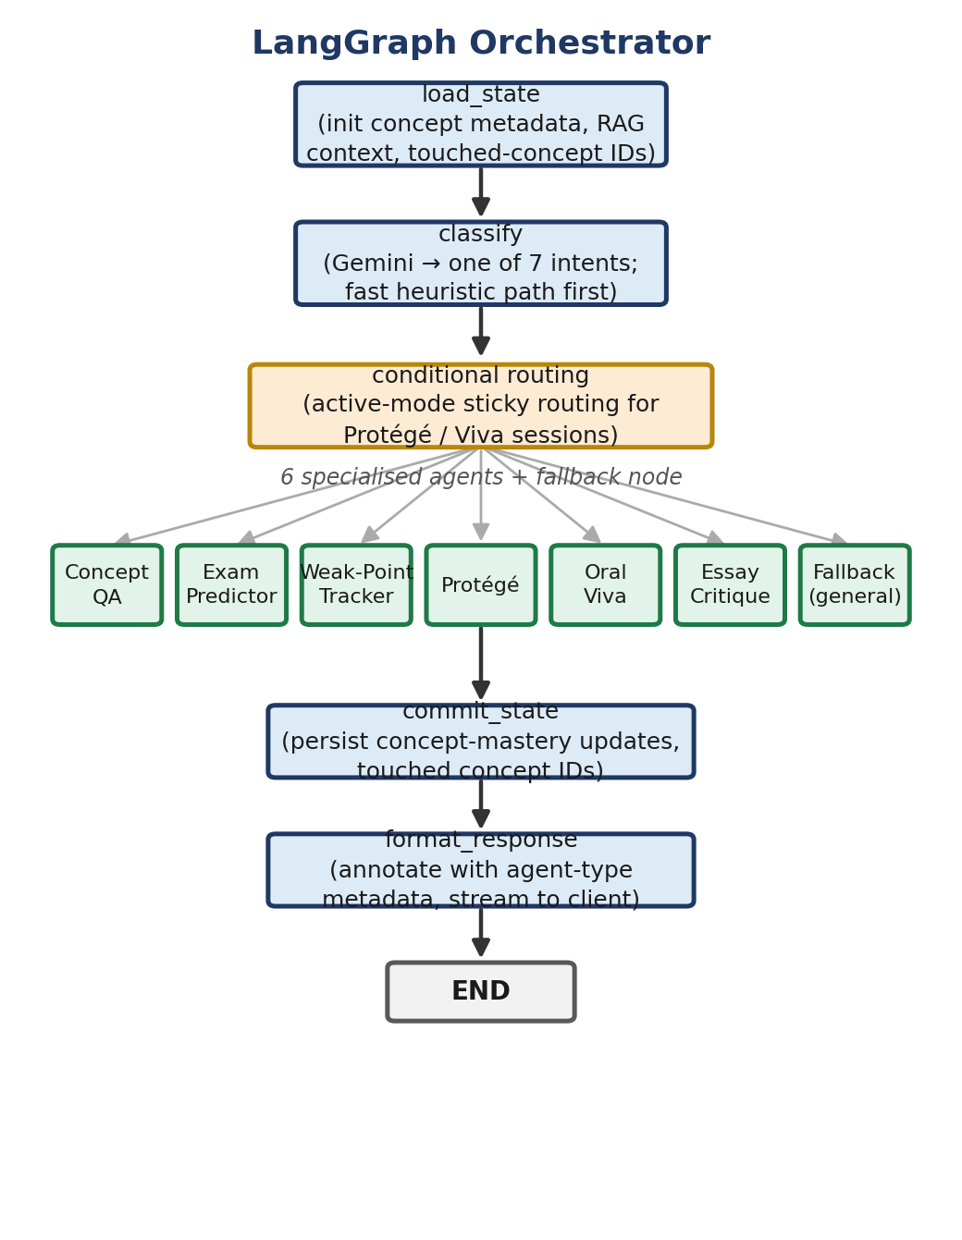
Fig. 2. The LangGraph orchestrator's five-step state graph. A rule-based fast path in the classify step resolves unambiguous intents (e.g. “quiz me on X”) without an LLM call; ambiguous messages still reach the Gemini-based classifier.
The classification prompt asks the model to return one of the following categories: conceptual_doubt (a question about concepts, definitions, or explanations), exam_prep (a request for practice questions, exam tips, or topic predictions), weak_points (a question about weaknesses, review needs, or study priorities), teach_me (an offer to explain or teach a concept, which triggers the Feynman-technique agent), viva (a request for oral examination or question-answer practice), critique (submission of an essay or piece of writing for review), or general (a greeting, meta-question, or off-topic message). The classifier is guided toward reliable routing by including example messages for each category directly in the classification prompt.
The orchestrator also supports multi-turn active modes: conversation metadata records an active_mode value once a student begins a Protégé teaching session or a Viva examination, so that subsequent messages bypass intent classification and are routed directly to the active agent. Students can exit an active mode using keywords detected in the classify node, such as 'end teaching', 'stop viva', or 'exit mode'.
B. Inter-Agent Collaboration
A distinctive feature of EduAgent is its inter-agent collaboration mechanism, implemented in the streaming service's _enrich_with_inter_agent_context function (Fig. 3). Before the selected agent generates a response, the system analyses the student's mastery state and extracts cross-agent intelligence relevant to the current interaction. This intelligence is added to the agent state's metadata as an inter_agent_context string, which the BaseAgent's prompt builder inserts into the LLM prompt as a 'Cross-Agent Intelligence' section.
For conceptual_doubt intents, the system identifies concepts with confidence below 0.4 (the weak-concept threshold) and issues a PREREQUISITE ALERT to the Concept QA agent, informing it of potential knowledge gaps so that basic misconceptions can be corrected before more advanced, dependent concepts are covered. For exam_prep intents, the system identifies concepts mastered above 0.8 (the mastery threshold) so that the Exam Predictor can skip them and focus practice on concepts the student has not yet mastered. For teach_me and viva intents, the system surfaces weak points as probing targets for the Protégé and Viva agents. For weak_points intents, overdue-review concepts are prioritised in the resulting recommendations. Table V summarises these four collaboration patterns.
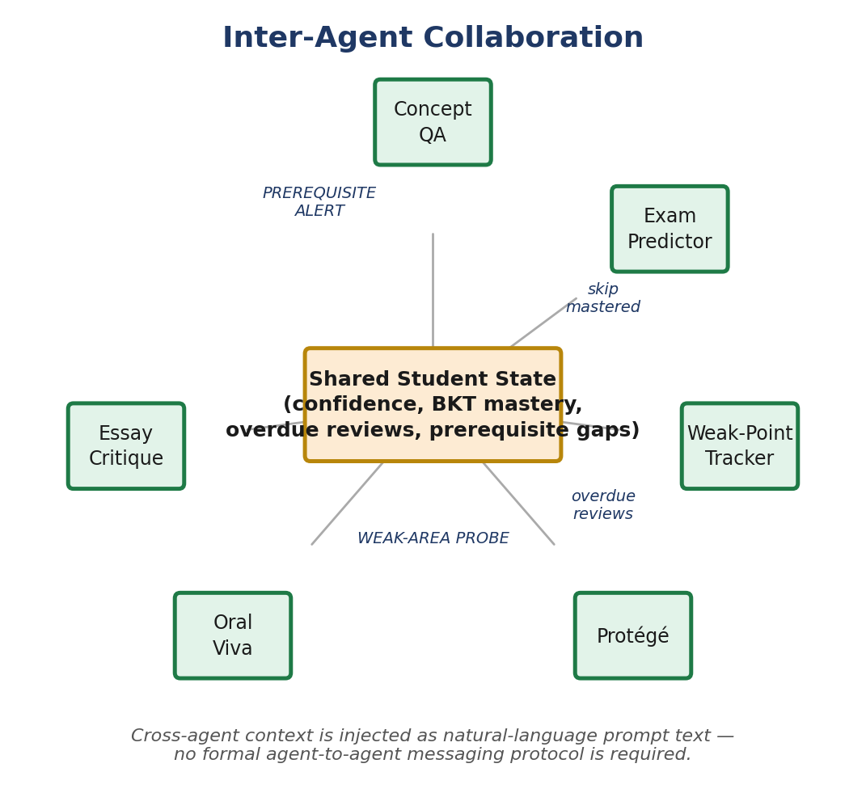
Fig. 3. Inter-agent collaboration as a hub-and-spoke pattern: every agent reads and writes one shared student-state record rather than messaging other agents directly, so cross-agent awareness costs no additional API round-trip.
This approach provides inter-agent awareness without implementing a formal agent-to-agent communication protocol. The collaboration module reads the shared student-state database and formats the relevant information as natural-language context for the LLM prompt, leveraging the model's own language-understanding capability to incorporate that context into its response.
C. Concept QA Agent
Concept QA is the most frequently invoked agent, handling conceptual doubts, definition requests, and explanatory queries. Its system prompt instructs the LLM to act as an expert teacher for the relevant topic, supplies the student's per-topic confidence levels and any identified prerequisite gaps, and includes the retrieved RAG context — passages from the course material relevant to the query — together with an explicit grounding instruction (Section X-E). The prompt asks the agent to explain concepts clearly using examples and analogies, to explain low-confidence concepts in greater depth, to fill identified prerequisite gaps, and to end each answer with a comprehension-check question.
The agent evaluates the student's understanding through LLM-based assessment rather than simple heuristics: the student's answer to the comprehension check is compared against the RAG ground truth to produce a quality rating (1–5), which the SM-2 algorithm uses to update the concept's mastery score. This closes the feedback loop as Explain → Check → Assess → Update mastery → Schedule review.
D. Exam Predictor Agent
The Exam Predictor evaluates syllabus coverage, topic weighting, and the student's level of understanding to anticipate likely exam topics and generate corresponding practice questions. Its system prompt includes the student's per-concept confidence scores, identified weak concepts, and RAG context spanning the full syllabus. The agent operates in two modes: prediction mode, which analyses curriculum coverage and student gaps to recommend focus areas and generate practice questions at an appropriate difficulty; and evaluation mode, which uses the LLM to compare a student's response to a generated question against the course material, giving detailed feedback on correctness, completeness, and areas for improvement.
Evaluation mode closes the practice–feedback loop: students receive real-time, contextualised feedback on their practice answers, together with quality ratings that update concept-mastery scores through the SM-2 algorithm.
E. Weak-Point Tracker Agent
The Weak-Point Tracker forms the metacognitive component of EduAgent, maintaining a picture of each student's knowledge landscape. It tracks SM-2 confidence scores across all enrolled concepts, flags concepts with confidence below 0.4, identifies concepts overdue for review (where the current date exceeds next_review_at), and produces prioritised study recommendations. Its system prompt includes a detailed mastery summary with confidence scores, attempt counts, and review schedules.
The agent is connected to a nudge engine that proactively surfaces reminders: whenever a student interacts with any agent, the nudge engine checks for overdue reviews and can append a friendly reminder to that agent's response. The Weak-Point Tracker itself provides a ranked list of weak concepts with suggested review strategies, a list of overdue items with days-overdue counts, a study-item ordering that combines low confidence with high overdue time, and mastery-progression summaries showing improvement trajectories.
F. Protégé Agent (Feynman Technique)
The Protégé agent applies the Feynman technique to deep learning, named for Richard Feynman's principle that understanding a concept means being able to explain it simply. The agent inverts the usual teaching order: the student teaches the AI, which plays the role of an inquisitive but naive learner. Its system prompt directs it to ask simple, probing questions that surface misconceptions, gaps, and strengths the student may not have recognised on their own. The agent tracks three kinds of evidence during the session: misconceptions (factual errors in the student's explanation), gaps (topics the student overlooks or glosses over), and strengths (well-explained concepts supported by good examples).
The interaction runs over a configurable number of exchanges (default five), during which the AI asks follow-up questions — requesting examples, analogies, or treatment of edge cases — to probe more deeply into the student's explanation. At the end of the session, the agent produces a structured assessment scored across four dimensions: clarity (how clearly the concept was explained), accuracy (factual correctness against the RAG source material), depth (coverage of sub-topics and nuance), and examples (quality and relevance of the examples given), with a score and detailed feedback for each dimension.
The Protégé agent updates concept confidence based on the overall quality of the teaching: confidence rises when the student demonstrates full understanding and gives correct examples, and falls when major misunderstandings or gaps are present, with a subsequent review scheduled through SM-2.
G. Oral Viva Agent
The Oral Viva agent emulates a viva-voce examination through a dynamic, difficulty-adaptive sequence of questions and answers. It offers three difficulty tiers — basic definitions and recall; application and analysis; and synthesis, evaluation, and edge cases — and formulates questions around concepts in the medium-confidence range (0.3–0.7), where students derive the greatest learning gains within their zone of proximal development.
Each viva session consists of a configurable number of questions (default five). After each answer, the agent gives structured feedback comprising correctness feedback grounded in the RAG material, points correctly covered, points the student missed, and a follow-up question matched to the current difficulty level. Difficulty adapts to performance: correct answers raise the difficulty, while incorrect answers trigger scaffolding and a difficulty decrease.
The Viva agent is paired with a Voice Mode component on the frontend, which uses the Web Speech API for browser-native speech-to-text (capturing student answers via SpeechRecognition) and text-to-speech (reading questions aloud via SpeechSynthesis). This gives the oral-examination experience a natural feel without relying on any external speech-processing service or incurring additional cost.
H. Essay Critique Agent
The Essay Critique agent provides structured, academic-style writing feedback with section-level rubric scoring. It assesses a piece of writing across five criteria: thesis (clarity, specificity, and argumentative quality of the main claim), evidence (quality, relevance, and sufficiency), analysis (depth of critical reasoning), organisation (structure, coherence, and paragraph transitions), and language (grammar, vocabulary, academic tone, and clarity). A score and concrete, actionable feedback are given for each dimension.
The agent also verifies factual claims in the essay against the RAG context, flagging discrepancies with the course material and instances where the student states a fact without citing a source. This dual focus — stylistic feedback alongside fact-checking — distinguishes the Critique agent from generic writing assistants. Table IV summarises all six agents, and Table V summarises the inter-agent collaboration patterns described in Section IV-B.
TABLE IV. EDUAGENT SPECIALISED AGENTS
Agent | Function | Key Technique | Assessment Method
Concept QA | Answers conceptual doubts with RAG context | Prerequisite-gap detection + adaptive depth | LLM-based comprehension check against ground truth
Exam Predictor | Generates practice questions; evaluates answers | Mastery-aware question generation | LLM evaluation with quality rating (1–5)
Weak-Point Tracker | Surfaces weak and overdue concepts | SM-2 scheduling + confidence decay | Confidence-threshold analysis (< 0.4)
Protégé | Student teaches the AI (Feynman technique) | Multi-turn probing + misconception tracking | 4-dimension rubric: clarity, accuracy, depth, examples
Oral Viva | Simulates an oral examination with voice | 3-tier difficulty ladder + Web Speech API | Per-question structured evaluation
Essay Critique | Structured academic-writing feedback | Fact-checking against RAG + citation analysis | 5-dimension rubric: thesis, evidence, analysis, organisation, language
TABLE V. INTER-AGENT COLLABORATION PATTERNS
Intent | Source Data | Injected Context | Effect on Agent
conceptual_doubt | Concepts with confidence < 0.4 | PREREQUISITE ALERT with weak-concept names | Agent addresses foundational gaps first
exam_prep | Concepts with confidence ≥ 0.8 | List of mastered topics to skip | Practice focuses on unmastered areas
teach_me / viva | Concepts with confidence < 0.4 | WEAK-AREA PROBE with struggle topics | Agent probes known weak areas
weak_points | Concepts past next_review_at | OVERDUE REVIEWS with concept names | Prioritises overdue items in recommendations
V. ADAPTIVE LEARNING ENGINE
EduAgent's adaptive learning engine combines several mechanisms for personalised learning: spaced-repetition scheduling, auto-generated flashcards, confidence decay, intelligent study planning, and automated concept-dependency detection. Together these mechanisms form a continuous learning loop that adapts to each student's demonstrated knowledge and retention pattern.
A. SM-2 Spaced Repetition Algorithm
EduAgent schedules concept review using the SM-2 algorithm [6]. The algorithm maintains three parameters for every concept and every student: repetitions, initially 0 and incremented by 1 after each successful review; interval_days, which follows the standard SM-2 schedule of one day for the first review, six days for the second review, and the previous interval scaled by the easiness factor for every subsequent review; and easiness_factor, initially 2.5 and updated after every review according to (1), floored at 1.3 so that a concept can never be scheduled so infrequently that it is effectively forgotten. As an agent evaluates a student's answer it produces a quality rating q on a 0–5 scale; if q < 3 (poor recall), the interval resets to one day and repetitions resets to 0, restarting the learning cycle for that concept. The easiness factor is updated after every review, regardless of quality, following
EF′ = max(1.3, EF + 0.1 − (5 − q) × (0.08 + (5 − q) × 0.02)). (1)
This rule lowers the easiness factor for low-quality responses, which shortens the subsequent review interval and schedules more frequent revisits for difficult concepts, while high-quality responses raise the easiness factor and lengthen future intervals; the 1.3 floor bounds how quickly the interval can grow so that a concept is never pushed too far into the future too soon.
Quality ratings are converted into confidence scores as
confidence = quality ⁄ 5.0, clamped to [0.0, 1.0], (2)
and these scores populate the mastery dashboard, drive weak-concept identification (confidence < 0.4), and order the study-priority queue. Eight unit tests validate the update function across perfect answers, poor answers, borderline responses, the easiness floor, the first- and second-repetition intervals, consecutive-review growth, and recovery from failure.
B. Auto-Generated Flashcards
During Concept QA discussions, the system extracts three to six question/answer fact pairs from the conversation and saves them as Flashcard records for later review. Each flashcard carries its own SM-2 scheduling parameters (easiness_factor, interval_days, repetitions, next_review_at, last_reviewed_at), independent of its parent concept's schedule, allowing individual facts — rather than whole concepts — to be tracked over time.
Students can also create flashcards manually through the frontend interface. The review screen presents each card with four response buttons — Forget, Hard, Good, Easy — mapped to an SM-2 quality level; each click triggers the SM-2 update function and adjusts the card's review schedule. Cards that are due (next_review_at ≤ now) appear at the top of the review queue, and the interface displays the number of due cards for each subject.
C. Confidence Decay
Concepts that go unreviewed past their due date lose confidence automatically, in proportion to how overdue they are. This mirrors the Ebbinghaus forgetting curve [16] and gives a more realistic picture of knowledge retention. When the dashboard or any agent loads the student's state, overdue concepts have their effective confidence lowered accordingly, so that the Weak-Point Tracker and the inter-agent collaboration module reflect the student's current knowledge state rather than its historical peak.
D. Smart Study Planner
Given an exam date and the student's available study hours per day, the planner retrieves the student's mastery summary, weak concepts, overdue reviews, and priority queue from the database, and assembles a detailed context prompt for Gemini containing the number of days remaining until the exam, the daily study time available, a prioritised list of concepts weighted by exam relevance and student confidence, and recommended activities per concept (review, practice questions, teach-back). Gemini allocates each concept and activity type to a time block within the daily schedule it produces. The resulting plan is saved to the study_plans table as JSONB, associated with a student, subject, and exam date, so that it can be retrieved and tracked over time.
E. Concept Dependency Auto-Detection
When a professor uploads course PDFs, the system can automatically infer prerequisite relationships between existing concepts by analysing the content with Gemini. The concept-graph service first extracts a syllabus outline from the PDF, then prompts Gemini to identify which concepts are prerequisites for which others, based on the material's logical structure. Detected prerequisite edges are inserted into the concept_prerequisites table, building the concept dependency graph without requiring professors to create edges manually. This substantially reduces the setup burden for new courses and helps ensure that the prerequisite structure reflects the material's actual pedagogical organisation.
VI. ADVANCED LEARNING INTELLIGENCE
While the SM-2 scheduler of Section V provides a robust heuristic for review timing, EduAgent augments it with six research-grade learning-intelligence engines that move the platform from reactive tutoring toward proactive, cognitively-aware personalisation. This section details the Bayesian Knowledge Tracing engine and its per-student parameter fitting, the predictive forgetting model and the learning-outcome predictor built on it, the Multi-Agent Debate mode, the Learning Genome, and the Knowledge Frontier.
A. Bayesian Knowledge Tracing
SM-2 conflates a single review outcome with mastery, so a lucky guess should not be read as understanding, nor should a single slip erase it. To model the latent state of knowledge more faithfully, EduAgent implements Bayesian Knowledge Tracing (BKT) [21], a two-state Hidden Markov Model (Fig. 4a) that maintains P(L), the posterior probability that a skill is truly learned. Neural sequence models such as Deep Knowledge Tracing [23] can capture more complex temporal patterns by learning latent representations directly from interaction sequences, but they do so at the cost of the closed-form interpretability that BKT's four named parameters provide; EduAgent adopts the classical BKT formulation so that mastery estimates remain explainable to both students and instructors, without requiring separate model-training infrastructure. The model is governed by four parameters: the prior P(L₀) that a skill is already known (default 0.10); the transition probability P(T) of moving from the unlearned to the learned state per practice opportunity; the slip probability P(S) of answering incorrectly despite mastery (0.10); and the guess probability P(G) of answering correctly without mastery (0.20).
After each observation the posterior is updated via Bayes' rule. For a correct response,
P(L∣correct) = P(L)(1−P(S)) ⁄ [P(L)(1−P(S)) + (1−P(L))P(G)]; (3)
for an incorrect response the slip and guess terms are exchanged,
P(L∣incorrect) = P(L)P(S) ⁄ [P(L)P(S) + (1−P(L))(1−P(G))]. (4)
A learning transition is then applied,
P(Lnext) = P(L∣obs) + (1 − P(L∣obs)) · P(T), (5)
where the transition rate is difficulty-aware: foundational concepts use P(T) = 0.20, while advanced concepts use P(T) = 0.10, so that harder skills require more evidence before being considered mastered. BKT mastery is stored per StudentConcept and updated within the same transaction as the SM-2 confidence update, so the two models advance together without additional LLM calls.
B. Predictive Forgetting
Complementing BKT, EduAgent models memory decay explicitly using the Ebbinghaus forgetting curve [16], expressing retrievability as
R(t) = exp(−t ⁄ S), (6)
where t is the number of days since the last review and S is the memory stability in days (Fig. 4b). Each successful review multiplies stability by a factor between 1.4 and 2.4, scaled by the current mastery level (the spacing effect) and capped at one year; each failure halves it. Solving R(t) = θ for the retention threshold θ = 0.5 gives
tforget = −S · ln(θ), (7)
the predicted day on which the concept will fall below the recall threshold. This timestamp (predicted_forget_at) drives a forgetting forecast that buckets upcoming at-risk concepts by day, letting the platform surface 'review before you forget' nudges rather than waiting for the SM-2 due date to pass. The current recall probability blends the forgetting curve with BKT mastery, reflecting the fact that well-consolidated skills decay more slowly. Section XI-E and Fig. 7 validate this mechanism against real per-concept stability values computed from a 45-day simulated usage trace.
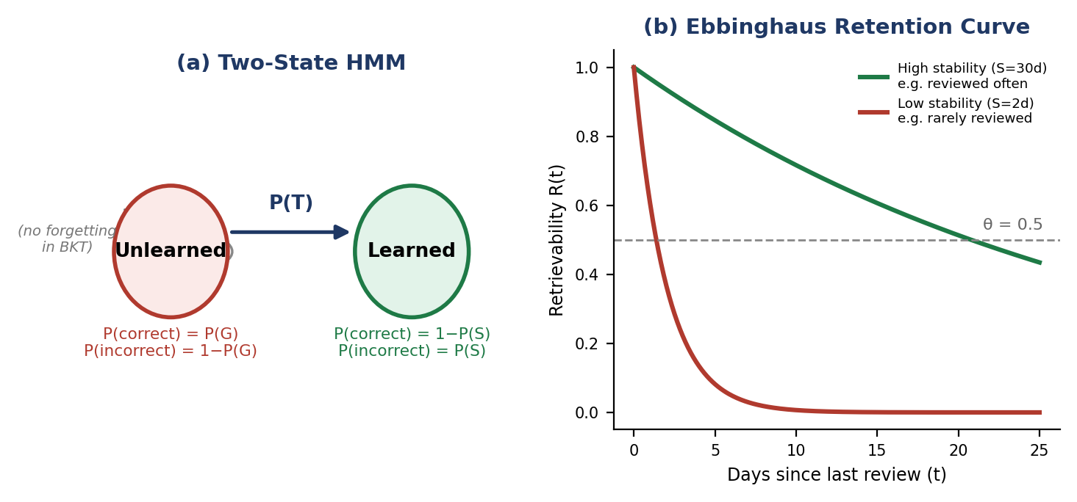
Fig. 4. (a) The BKT two-state Hidden Markov Model: a learning transition P(T) moves a skill from Unlearned to Learned, with no reverse transition — forgetting is instead modelled separately (b) by the Ebbinghaus retention curve R(t) = exp(−t/S), whose stability parameter S is what actually decays a concept's predicted recall over time.
C. Multi-Agent Debate and Consensus
For ambiguous or contested questions, a single tutor response can be unclear or can quietly propagate a subtle error. Taking inspiration from structured multi-agent reasoning frameworks [4], [5], [13], EduAgent engages three RAG-grounded LLM personas in a structured debate over the course material. A Proponent argues the strongest case for the clearest current textbook interpretation; a Skeptic critiques that position, raising edge cases, alternative interpretations, and common misconceptions; and a neutral Judge synthesises a consensus that favours neither side and assigns an explicit confidence rating to the material. Optional rebuttal rounds let the Proponent respond to the Skeptic before adjudication. The exchange is streamed to the client turn by turn over Server-Sent Events. Rather than concealing disagreement within a single chain-of-thought answer, the debate format exposes it directly, giving students a better-calibrated sense of confidence and modelling how professionals reason under uncertainty.
Section VII-E extends this AI-only format with a peer-debate variant in which two students, rather than two AI personas, each state a position and the same RAG-grounded Judge moderates — preserving the neutral-synthesis mechanism while moving the object-level reasoning from the model to the students themselves.
D. The Learning Genome
The Learning Genome is an agent-agnostic, per-student cognitive fingerprint computed from behaviour rather than self-report: pace is the mean number of attempts required to reach mastery; session length is derived from a 30-minute gap between consecutive message timestamps; preferred modality is the most frequently used agent type; persistence is the fraction of weak concepts a student returns to; and peak study hour is the hour of day at which the student is most active. A lightweight LLM pass summarises recent messages to surface recurring misconception patterns. As of Section VII-F, the genome additionally derives a collaboration_score from study-room membership and authored material annotations, so a student's social learning behaviour is reflected alongside their solo study pattern. These signals are woven into a natural-language summary that is injected into every agent's system prompt — for example, a slow-paced learner receives extra scaffolding and more frequent comprehension checks, while a fast-paced learner receives challenge extensions. The genome is stored in a dedicated learning_genomes table and refreshed as interaction data accumulates, providing a single personalisation layer shared by all six specialised agents. Every trait is left null, not defaulted, until it is actually observed, so a student with no relevant activity yet is never shown an invented habit as if it were real.
E. The Knowledge Frontier (Zone of Proximal Development)
The Knowledge Frontier operationalises Vygotsky's Zone of Proximal Development (ZPD) [22], the region of knowledge a learner can reach with appropriate support. The engine partitions a student's concept graph into three sets: mastered concepts (own mastery ≥ 0.70); locked concepts, blocked by at least one prerequisite with low mastery; and frontier concepts — not yet mastered, but with every prerequisite mastered at ≥ 0.60 — which constitute the student's ZPD. Frontier concepts are ranked by a readiness score that favours concepts already central to the learning outcomes while discounting those still far from mastery, producing a 'learning GPS' that recommends the single best next concept to study and lets each new concept build directly on what has already been mastered. This makes the concept map interactive and individualised, taking each student's full prerequisite structure into account. Fig. 5 shows a worked example drawn directly from the simulated validation trace of Section XI-E: Processes and Threads are mastered and unlock Paging, whose own mastery in turn opens up Segmentation and Virtual Memory as frontier concepts, while File Systems remains too weak to unlock Disk Scheduling or I/O Management, which stay locked.
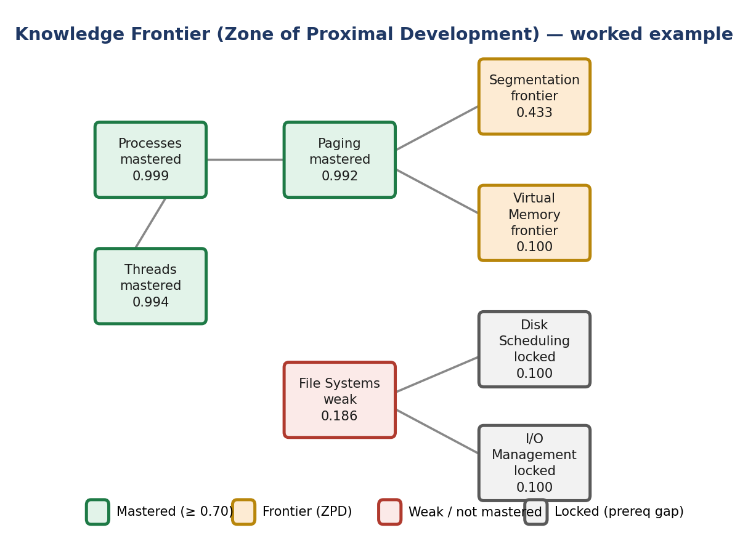
Fig. 5. Knowledge Frontier partition for the simulated validation student (Section XI-E). Mastery values are the actual BKT posteriors computed by the running system, not illustrative placeholders.
F. Personalised BKT Parameter Estimation via Expectation–Maximisation
The global BKT defaults of Section VI-A — P(L₀)=0.10, P(S)=0.10, P(G)=0.20, and the difficulty-tiered P(T) values — are reasonable population-level priors, but they are the same for every student regardless of how that student's own observed correct/incorrect sequence actually behaves. EduAgent now fits these four parameters per student via the classical Baum–Welch expectation–maximisation procedure for hidden Markov models [24]. Every BKT observation is logged verbatim to a bkt_observations table (student, concept, difficulty tier, correct/incorrect, timestamp); once a student has accumulated at least eight such observations, the E-step runs the forward–backward algorithm over each concept's observation sequence to obtain the posterior P(learned) at every timestep, and the M-step re-estimates P(L₀) (the mean starting posterior across sequences), P(S) and P(G) (from the soft-counted correct/incorrect outcomes conditioned on the inferred latent state), and a per-difficulty-tier P(T) (from soft-counted unlearned-to-learned transitions), iterating for eight passes. The fitted parameters are cached in student_bkt_params and used by apply_bkt_observation in place of the global defaults for every subsequent observation from that student; a student below the eight-observation threshold continues to use the population defaults rather than being fitted on noise. Section XI-E reports the parameters this procedure recovered for the simulated validation student as a concrete illustration of the method's output.
G. Learning-Outcome Prediction
Beyond forecasting when a single concept will be forgotten (Section VI-B), instructors and students alike want an answer to a more direct question: if the exam were held on a given date, how would the student do right now? The learning-outcome predictor answers this by projecting every enrolled concept's forgetting curve forward to a target exam date, blending the projected recall with the concept's current BKT mastery in equal weight so that a well-understood but stale concept and a freshly-reviewed but shallow one are both penalised appropriately, and averaging the result across all enrolled concepts into a single predicted score together with a readiness label (strong / moderate / at risk) and the specific concepts driving the risk. Because it reuses the same retrievability function as Section VI-B with an arbitrary future timestamp rather than the present moment, no additional model or calibration step is required. Section XI-E reports this prediction for the simulated validation student 14 days out from their last recorded activity.
VII. COLLABORATION AND REAL-TIME FEATURES
EduAgent extends beyond individual learning to support collaborative educational experiences through WebSocket-based study rooms, a shared whiteboard, AI-moderated peer debate, collaborative material annotation, voice interaction, and multimodal content understanding.
A. WebSocket Study Rooms
Students can create or join study rooms to hold collaborative learning sessions. Each room has a subject focus and a configurable membership cap (default five), and tracks which students have joined. The WebSocket endpoint for a study room (/ws/study-room/{room_id}) requires JWT authentication to connect, with user identity extracted from the JWT payload. The server maintains a connection pool per room and tracks each pool's active WebSocket connections for broadcast operations.
Text messages sent by any room member are relayed in real time to the other members. The WebSocket handler recognises message types for plain chat (human-to-human messages broadcast to all members), an ai_question type directed at the AI assistant, and — introduced in this revision — whiteboard, debate, and annotation message types described below. When a student sends an ai_question message, the server invokes the Concept QA agent with the room's subject as context, and the agent's answer is broadcast to every room member, turning the AI agent into a shared resource for the whole study group. This design supports social learning by letting students discuss ideas with one another and pose questions to the AI together.
B. Voice Mode
The Oral Viva agent supports voice interaction through the Web Speech API via a VoiceMode React component, which wraps two browser APIs: SpeechRecognition, which captures and transcribes the student's spoken response for submission to the agent, and SpeechSynthesis, which reads the agent's text responses aloud. The component provides record/stop controls, a live transcript display, and adjustable speech parameters (rate, pitch, language).
Because it is entirely browser-native, this approach offers several advantages: no dependency on a cloud speech service, low latency since speech is processed locally in the browser, support for multiple languages depending on the browser, and no additional server-side audio-processing infrastructure. Voice interaction is particularly valuable for the Oral Viva agent, since an authentic sense of pacing and delivery is difficult to convey through a purely text-based oral-examination simulation.
C. Multimodal Image Understanding
Students can submit diagrams, flowcharts, circuit diagrams, mathematical notation, or handwritten notes through the ImageUpload component. The uploaded image is base64-encoded and sent to the backend together with the student's question; the backend forwards both to Google Gemini's multimodal endpoint (gemini-2.0-flash), which processes the image and text query jointly.
The system can explain elements of an attached diagram (for example, identifying gates in a circuit diagram), point out errors in a hand-drawn flowchart, transcribe and interpret handwritten notes, walk through the solution steps of a photographed mathematical problem, and give feedback on a hand-drawn concept map. This multimodal capability lets EduAgent support non-text learning modalities that are especially important for visual reasoning in STEM education.
D. Collaborative Whiteboard
A live, shared drawing surface is available inside every study room. Freehand strokes — a colour, a width, and an ordered list of points — are broadcast to every other connected member over the same room WebSocket the moment the pointer is released, and are kept in a per-room, in-memory stroke log so that a student joining mid-session receives the room's current drawing state as a single whiteboard_history message rather than an empty canvas. The whiteboard is deliberately ephemeral — scoped to the live session rather than persisted — since it functions as a scratch space for worked examples and diagram sketching during a call, not as durable course material; durable, shareable notes are instead handled by material annotation (Section VII-F).
E. Peer-Debate Mode
Section VI-C's AI-only Proponent/Skeptic/Judge format is extended with a peer-debate mode in which the two object-level positions come from real students rather than AI personas. Any room member can propose a debate topic, which resets the room's shared debate state; each participant then submits their own written position, visible to the whole room as it arrives; and any participant can then request an AI verdict, at which point the same RAG-grounded Judge persona used in Section VI-C is invoked — now moderating between the students' actual arguments rather than between a Proponent and a Skeptic — naming a specific strength in each student's position, judging which side the course material better supports (or declaring a genuine tie), and closing with an explicit confidence rating. This keeps the neutral, RAG-grounded adjudication mechanism of the AI-only debate while moving the actual reasoning and disagreement to the students, directly addressing the social-learning extension identified as future work in earlier iterations of this platform.
F. Collaborative Material Annotation
Students can pin a note to a specific page of a subject's uploaded material — optionally alongside a short highlighted excerpt — through a material_annotations record tied to the subject, the source file and page, and the authoring student. Unlike the whiteboard, annotations are persisted: they outlive the study-room session that produced them and remain visible to anyone later revisiting that page of the material, with the originating room retained only as provenance. When authored during a live room session, a lightweight broadcast message additionally notifies everyone currently connected so the annotation appears immediately rather than only on the next page load. Authored annotations also feed the Learning Genome's collaboration_score (Section VI-D), giving persistent, low-effort note-sharing the same personalisation weight as active study-room participation.
VIII. ANALYTICS AND OBSERVABILITY
EduAgent provides analytics and observability features for both students and administrators, enabling data-driven insight into learning progress and system performance.
A. Agent Performance Logging
Every agent invocation is recorded in the agent_logs table, capturing student_id, conversation_id, agent_type, intent (the classified intent type), response_time_ms (end-to-end response-generation time), input_tokens and output_tokens (approximate token counts), rag_chunks_used (number of retrieved context passages), success (whether the request completed successfully), error_message (populated on failure), and created_at. This granular logging supports monitoring of agent usage patterns, response-time distributions by agent type, error-rate tracking, and identification of performance bottlenecks.
B. Class-Level Analytics Dashboard
An administrator dashboard aggregates class-wide metrics per subject: average mastery across all enrolled students, top weak concepts with the number of struggling students, enrolled-student count, interactions by agent type, and intent-classification distribution. These figures let a professor adapt the curriculum to observed data — for example, devoting more lecture time or additional readings to a concept where the majority of students show low confidence.
The analytics endpoints rely on Redis caching to avoid costly SQL aggregations on every dashboard load, with a five-minute cache TTL. Cache keys are generated by MD5-hashing the query parameters and are automatically invalidated when the underlying data changes.
C. Learning Path Timeline
Significant learning events are persisted as LearningEvent records, with event_type drawn from concept_learned, concept_reviewed, concept_mastered, weak_point_identified, flashcard_created, or study_plan_generated, together with concept_id, subject_id, agent_type, a JSONB data field for additional metadata, and an event-specific created_at timestamp. These events are rendered as an interactive timeline, sorted by date and colour-coded and iconised by event type, giving students a visual record of their learning progress and behavioural patterns over time.
D. Progress Report PDF Export
Students can download a ReportLab-generated PDF report containing a mastery summary at chapter and overall levels, chapter-breakdown tables with per-concept mastery scores and next review dates, a weak-points summary with priority tags (critical/high/medium/low), a study-priority queue ordered by next review date, and a list of overdue items. The PDF is generated on demand by the /api/reports/progress endpoint and returned to the client as a downloadable file.
E. Intent Distribution Analysis
The analytics system also breaks down what students are using the platform for, based on classified intent, over time. Administrators can see whether students are primarily seeking conceptual understanding (conceptual_doubt), practising questions (exam_prep), or reinforcing confidence (weak_points, teach_me, viva). This usage-pattern data can inform platform-development priorities and help professors stay aware of how students are actually engaging with the material.
IX. CUSTOM AGENT BUILDER
EduAgent offers a custom agent builder that lets professors create domain-specific agents without writing code. Each custom agent has four properties, stored in the custom_agents table: Agent Name (a short label, e.g. 'Lab Report Reviewer' or 'Case Study Analyser'); Description (an explanation of the agent's purpose); System Prompt (the complete prompt defining the agent's behaviour, personality, assessment criteria, and response style, fed directly into the LLM call alongside RAG context and student messages); and Rubric (an optional JSONB set of scoring dimensions and criteria).
Custom agents reuse the same core infrastructure as the six built-in agents — RAG retrieval for course-grounded context, SSE streaming for token-by-token responses, and LLM-based assessment of response quality. Professors can create, edit, and deactivate custom agents through an admin-interface form that includes an active/inactive toggle.
Representative use cases include a Lab Report Reviewer that assesses methodology description, results presentation, and analysis quality; a Case Study Analyser that evaluates problem-solving approach, stakeholder identification, and solution feasibility; a Code Review Agent that checks code quality, algorithmic correctness, and documentation completeness; and a Debate Coach that analyses argumentative structure, evidence use, and rhetorical effectiveness. This extensibility lets EduAgent adapt to learning contexts beyond those covered by its built-in agents.
X. IMPLEMENTATION DETAILS
A. Backend Implementation
The backend is built on Python 3.11+ with FastAPI, and comprises 20 API routers; 14 services (student_state, streaming, cache, analytics, flashcard_service, planner_service, pdf_report, concept_graph, auth, knowledge_tracing, knowledge_frontier, learning_genome, llm_provider, and the debate orchestrator); six specialised agent subclasses plus a shared BaseAgent superclass, together with a multi-agent debate orchestrator; and 20 database models across nine files, including the LearningGenome, StudentBktParams, BktObservation, and MaterialAnnotation models.
The architecture maintains a clear separation of responsibilities between routers (handling HTTP requests and responses), services (business logic and database operations), and agents (LLM prompt construction and response parsing).
User authentication uses JSON Web Tokens with bcrypt password hashing, role-based access control for students and administrators, and token-refresh support. Registration and login payloads are validated with Pydantic's EmailStr type rather than a bare string, so a malformed address is rejected by the schema layer before it ever reaches the database. The REST API ships with auto-generated OpenAPI documentation, available at the /docs endpoint.
B. Frontend Implementation
The frontend is built with Next.js 16 and TypeScript across 19+ pages and 15+ components. Key architectural elements include the App Router for file-based routing, a dashboard layout wrapper with a collapsible sidebar, Zustand stores for chat state (messages, conversations, streams), and React Query for server-state caching and synchronisation.
UI components draw on the shadcn/ui library, a wrapper around Radix UI that provides accessibility support (ARIA attributes, keyboard and focus navigation), styled with TailwindCSS for responsiveness. A ThemeToggle component supports dark mode, persisting the user's preference in localStorage and otherwise following the system theme, and React error boundaries catch rendering errors and present a fallback UI with a retry option.
C. Containerisation and Deployment
The application is packaged with Docker Compose, with separate development and production configurations: the development compose file enables hot reloading, while the production compose file uses a multi-stage Dockerfile (build and run stages) to optimise image size, together with health checks (PostgreSQL readiness, Redis ping, backend liveness), resource constraints, and restart policies.
The five containerised services are PostgreSQL 16 (official image with volume persistence), Qdrant (official image with collection storage), Redis 7 (official image with append-only-file persistence), the FastAPI backend (custom Dockerfile with a uvicorn ASGI server), and the Next.js frontend (custom Dockerfile with standalone output mode). Two seed scripts populate the database for demonstration and validation purposes: scripts/seed_demo.py populates four subjects (MSA, HCI, Cyber Security, ML) with 15–20 concepts per subject and representative confidence-score values, while scripts/seed_full_history.py (introduced in this revision, Section XI-E) drives the real BKT, forgetting-curve, and Learning-Genome computation code through a chronologically simulated 45-day usage trace for one student, rather than inserting pre-computed values directly.
D. Testing
The test suite comprises more than 130 automated tests across three levels. Backend unit tests cover the SM-2 algorithm (8 tests spanning all branches), password hashing and verification, Bayesian Knowledge Tracing (14 tests covering posterior updates, mastery updates, memory-stability, and forgetting-curve calculations, plus dedicated forward–backward and EM-fitting tests for the per-student parameter estimation of Section VI-F), Knowledge Frontier readiness-score computation and partitioning (12 tests), multi-agent debate context formatting and prompt templates including the peer-debate judge prompt (Section VII-E), Learning Genome summary construction, modality labelling, and the collaboration-score formula (Section VI-D), collaborative-annotation CRUD and ownership rules (Section VII-F), and supporting utility functions. Backend integration tests cover intent classification, student-state handling, nudge-engine behaviour, dashboard-endpoint responses, the orchestrator graph, and API-endpoint authentication. Frontend tests use Vitest, React Testing Library, and jsdom, including six tests for Zustand chat-state management alongside rendering and interaction scenarios.
Test infrastructure includes pytest fixtures for database sessions and test clients (conftest.py), pytest-asyncio for asynchronous test support, httpx for asynchronous HTTP testing, and pytest-cov for coverage reporting. The suite is designed to run in CI/CD pipelines with minimal setup, requiring only a test-database connection string.
E. Multi-Provider LLM Abstraction and Hallucination Mitigation
Two robustness concerns were identified through direct end-to-end testing of the deployed system rather than from code review alone: dependence on a single LLM vendor, and the risk of a fact-answering agent presenting an ungrounded answer with unwarranted confidence.
First, every LLM call in the original implementation went through a single Gemini client. All six specialised agents' reasoning steps, and the shared streaming path in BaseAgent, now go through a common LLMProvider interface with Gemini, OpenAI, and Anthropic implementations; the active provider is selected by a single configuration value and falls back to Gemini automatically if the configured alternative's API key is absent, so an incomplete deployment configuration degrades gracefully rather than failing outright. Gemini remains the default and most thoroughly evaluated provider throughout this paper.
Second, every fact-answering agent's prompt (Concept QA, Exam Predictor, Weak-Point Tracker, Oral Viva, and Essay Critique) now appends an explicit grounding instruction: prefer the retrieved course material over general knowledge when the two would conflict, state plainly when the retrieved context is insufficient rather than inventing specifics, and never fabricate exact numbers, citations, or quotations absent from the retrieved context or conversation history. This alone does not guarantee a grounded answer, so a lightweight post-hoc check is applied to the generated response: if the best retrieval-similarity score for the turn falls below a configurable threshold (0.35 by default) while the response reads as an unhedged, confident answer, or if the response shares almost no vocabulary with the retrieved passages despite context being available, a visible confidence caveat is appended advising the student to verify the specifics independently. Responses that already hedge on their own (for example, explicitly stating that the material does not cover the question) are left unmodified. This is a lexical heuristic rather than a fact-checker — it is designed to catch gross ungrounded-confidence failures, not subtle factual errors — and it is intentionally not applied to the Protégé agent's Socratic role-play, where the agent is not asserting facts, or to the existing Multi-Agent Debate personas, whose Proponent/Skeptic/Judge structure already surfaces uncertainty by design. A concrete failure this mechanism was built to prevent, and subsequently caught during development, is described in Section XII-D.
TABLE VI. KEY FEATURES SUMMARY
Feature | Description | Implementation
Inter-Agent Collaboration | Agents consult weak points, mastery, and overdue data | Prompt-level context injection via _enrich_with_inter_agent_context
Auto-Generated Flashcards | LLM extracts Q/A pairs from conversations | Gemini extraction + independent SM-2 scheduling per card
Smart Study Planner | AI day-by-day schedule based on mastery and exam dates | LLM plan generation, stored as JSONB
Voice Mode | Speech-to-text input and text-to-speech output | Web Speech API (SpeechRecognition + SpeechSynthesis)
Image Understanding | Diagram and handwritten-note analysis | Gemini multimodal endpoint with base64 image encoding
Study Groups | WebSocket rooms with a shared AI assistant | Per-room connection pools with JWT authentication
Custom Agent Builder | Admin-defined agents with prompts and rubrics | JSONB rubric storage + BaseAgent infrastructure reuse
Class Analytics | Aggregated mastery, weak concepts, agent performance | Redis-cached SQL aggregations with 5-min TTL
Progress PDF Export | Downloadable mastery reports | ReportLab tables and charts streamed as PDF
Learning Path Timeline | Chronological learning-event visualisation | LearningEvent records rendered as an interactive timeline
Concept Auto-Detection | LLM infers prerequisite edges from PDFs | Gemini analysis of extracted syllabus content
Redis Caching | Reduced API calls and faster responses | MD5-hashed keys with configurable TTL
Bayesian Knowledge Tracing | HMM-based per-concept mastery estimation | BKT posterior update + difficulty-scaled P(T); stored per StudentConcept
Personalised BKT (EM) | Per-student P(L₀)/P(T)/P(S)/P(G), not global defaults | Baum–Welch forward–backward EM over the raw observation log (Sec. VI-F)
Predictive Forgetting | Ebbinghaus curve forecasts recall decay | R(t) = exp(−t/S); stability growth on success; proactive review alerts
Learning-Outcome Prediction | Forecasts assessment readiness for a future exam date | Forgetting-curve projection blended with current BKT mastery (Sec. VI-G)
Multi-Agent Debate | Proponent / Skeptic / Judge structured debate | RAG-grounded; SSE-streamed turns; optional rebuttal rounds
Peer-Debate Mode | Two students argue, AI moderates and adjudicates | Same Judge persona over real student positions (Sec. VII-E)
Collaborative Whiteboard | Live shared drawing surface in a study room | Per-room in-memory stroke log broadcast over WebSocket (Sec. VII-D)
Material Annotation | Persisted notes pinned to a page of course material | material_annotations table + live room broadcast (Sec. VII-F)
Learning Genome | Per-student cognitive fingerprint, incl. social signals | Behavioural + LLM misconception detection + room/annotation activity
Knowledge Frontier (ZPD) | Concept graph partitioned by mastery and prerequisites | Mastered / frontier / locked sets; readiness-ranked next-best recommendation
Multi-Provider LLM | Gemini, OpenAI, or Anthropic behind one interface | Provider abstraction with automatic fallback to Gemini (Sec. X-E)
Hallucination Mitigation | Grounding instructions + post-hoc confidence caveat | Retrieval-score and lexical-overlap check on generated responses (Sec. X-E)
XI. EVALUATION
A. User Study Protocol
A structured protocol has been developed to evaluate EduAgent's educational effectiveness and usability, comprising two stages: guided tasks and a post-task survey.
The guided tasks span five increasingly complex activities: (1) Concept Q&A, in which the participant poses conceptual questions and receives RAG-grounded answers, testing the effectiveness of the Concept QA agent; (2) Practice Questions, in which the participant requests exam preparation, answers generated questions, and receives feedback, testing the assessment accuracy of the Exam Predictor; (3) Weak-Point Analysis, in which the participant reviews identified weak points and study recommendations, testing the Weak-Point Tracker as a metacognitive tool; (4) Protégé Mode, in which the participant explains a concept to the AI and receives structured feedback, testing the Feynman-technique implementation; and (5) Dashboard Review, in which the participant uses the concept map, mastery dashboard, and flashcard review, testing the platform's visualisation capabilities.
B. Survey Instrument
The survey instrument is a 21-item, five-point Likert-scale questionnaire spanning five sub-scales: Usability (5 items: interface intuitiveness, response clarity, navigational ease, loading speed, error handling); Educational Effectiveness (5 items: explanation quality, relevance of practice questions, feedback quality, concept understanding, study motivation); Visualisation Quality (3 items: clarity of the concept map, informativeness of the mastery dashboard, usefulness of learning paths); Agent Quality (5 items: accuracy of intent classification, response relevance, coherence across agents, quality of Protégé feedback, relevance of Viva questions); and Alternative Comparison (3 items: comparison with ChatGPT, comparison with conventional study methods, likelihood of continued use). The System Usability Scale (SUS) [17] is additionally administered for comparison against the industry-average benchmark of 68.
C. Quantitative Metrics
Quantitative metrics recorded through the AgentLog system include mean agent response time (target < 5 seconds), intent-classification accuracy (classified intents compared against human-labelled ground truth), improvement in concept mastery (the change in StudentConcept confidence score between sessions), flashcard recall rate (the proportion of due flashcards answered correctly), and study-plan adherence (concepts reviewed relative to concepts planned).
D. Preliminary Results
Early trials with five pilot users produced encouraging qualitative feedback. Participants found the multi-agent system easier to use than single-chatbot alternatives, since it adapted automatically to the type of question asked. The Protégé feature was highlighted as particularly effective at surfacing gaps in understanding that students had not recognised themselves, and the mastery-coloured concept-map visualisation was noted as a strong motivational tool. These five-user trials remain qualitative and are not a substitute for the fully powered, statistically analysed study described in Sections XI-A–C, which is still planned as a follow-up to this paper (Section XII-E). Section XI-E below reports a complementary, fully reproducible form of evidence: a simulated but code-faithful usage trace that exercises every adaptive mechanism described in Sections V–VI end-to-end and reports exactly what the running system computed.
E. Illustrative System Validation: A Simulated 45-Day Usage Trace
Sections XI-A–D describe EduAgent's plan for evaluating learning-outcome efficacy with real students; that study has not yet been completed, and no claim of pedagogical efficacy is made here. What can be reported now, and reproduced by any reader from the open-source repository, is that the adaptive machinery itself — BKT, predictive forgetting, EM parameter fitting, the Knowledge Frontier, and the Learning Genome — runs correctly end-to-end and converges to internally consistent, explainable state. To demonstrate this, scripts/seed_full_history.py drives one synthetic student through a chronologically ordered 45-day interaction history against a 12-concept Operating Systems subject, deliberately varied so that some concepts are studied intensively and reviewed regularly, some are studied briefly and then neglected, and some are never attempted at all. Critically, every downstream value in this subsection — BKT mastery, memory stability, the EM-fitted parameters, the Knowledge Frontier partition, the Learning Genome, and the outcome prediction — is computed by calling the same production functions described in Sections V and VI on that history, not hand-entered; this is a validation of the pipeline's correctness and internal consistency under a controlled, known input, not a study of human learning outcomes.
Table VII reports the resulting per-concept BKT mastery before any interaction (Day 0, the shared P(L₀)=0.10 prior) against the same value after the 45-day trace (Day 45), alongside the number of attempts recorded and the resulting Knowledge Frontier status; Fig. 6 plots the same before/after comparison. Four qualitatively different trajectories are visible by design: Processes, Threads, Process Scheduling, Synchronisation, and Paging were reviewed regularly and reach near-ceiling mastery (≥ 0.98); Semaphores and Segmentation were touched only a handful of times and land in the intermediate range; Deadlocks was attempted seven times but with a majority-incorrect response pattern and stays low (0.276), correctly surfacing it as the platform's top weak-point recommendation; and Virtual Memory, Disk Scheduling, and I/O Management were never attempted and remain at the untouched prior, with Disk Scheduling and I/O Management additionally reported as Knowledge-Frontier-locked because their shared prerequisite, File Systems, itself never exceeds 0.19 mastery.
TABLE VII. SIMULATED 45-DAY VALIDATION TRACE: PER-CONCEPT BKT MASTERY, BEFORE VS. AFTER
Concept | Attempts | Day 0 (before) | Day 45 (after) | Frontier status
Processes | 6 | 0.100 | 0.999 | Mastered
Threads | 4 | 0.100 | 0.994 | Mastered
Process Scheduling | 6 | 0.100 | 0.983 | Mastered
Synchronisation | 6 | 0.100 | 1.000 | Mastered
Paging | 4 | 0.100 | 0.992 | Mastered
Semaphores | 4 | 0.100 | 0.671 | Developing
Segmentation | 1 | 0.100 | 0.433 | Frontier (ZPD)
Deadlocks | 7 | 0.100 | 0.276 | Weak point (top-ranked)
File Systems | 4 | 0.100 | 0.186 | Weak point
Virtual Memory | 0 | 0.100 | 0.100 | Frontier (ZPD)
Disk Scheduling | 0 | 0.100 | 0.100 | Locked (File Systems gap)
I/O Management | 0 | 0.100 | 0.100 | Locked (File Systems gap)
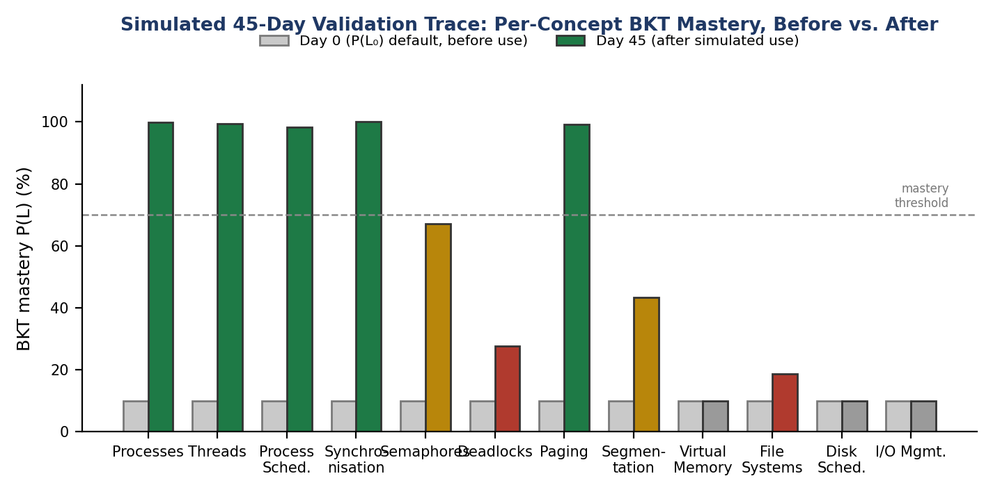
Fig. 6. Table VII plotted: every concept starts at the shared P(L₀) prior (grey) on Day 0; the Day-45 bar (coloured by resulting status — green: mastered, amber: frontier/developing, red: weak, grey: untouched) is the system's own computed output, not a hand-set target.
Table VIII reports the BKT parameters the expectation–maximisation procedure of Section VI-F recovered from this student's 42 logged observations across 9 attempted concepts — comfortably above the 8-observation minimum — against the tuned global defaults every student starts from. The fitted slip and guess probabilities are both higher than the defaults, consistent with a synthetic trace that deliberately included a substantial share of incorrect responses (Deadlocks and File Systems in particular); this is the expected behaviour of the estimator, not an error, and is exactly the kind of per-student divergence from a population default that motivated implementing per-student fitting in the first place.
TABLE VIII. EM-FITTED BKT PARAMETERS (42 OBSERVATIONS, 9 CONCEPTS) VS. GLOBAL DEFAULTS
Parameter | Global default | EM-fitted (this student)
P(L₀) — prior mastery | 0.100 | 0.310
P(S) — slip | 0.100 | 0.210
P(G) — guess | 0.200 | 0.373
P(T), tier 1 (foundational) | 0.200 | 0.600
P(T), tier 2 (intermediate) | 0.150 | 0.600
P(T), tier 3 (advanced) | 0.100 | 0.100

Beyond individual concepts, Section VI-G's learning-outcome predictor was run for this student projected 14 days forward from their last recorded activity: it returned a predicted overall exam score of 35.7% with an “at risk” readiness label, driven primarily by the five near-ceiling concepts' recall decaying substantially over the 14-day gap (e.g. Processes' projected recall falls to 0.255 despite 0.999 current mastery) rather than by the concepts that were never mastered in the first place — correctly distinguishing “forgot what they knew” from “never learned it”, which a mastery-only snapshot would not. The Learning Genome computed from the same trace independently converged on a consistent behavioural picture without being told any of the design intent above: a slow-paced learner who prefers conceptual Q&A, most active around 19:00, showing moderate persistence, with an LLM-derived misconception summary that named Deadlocks, Process Scheduling, and Synchronisation — precisely the concepts the seeded conversation history was written to make the student ask confused, clarification-seeking questions about — and a collaboration_score of 0.45 from two study-room memberships and three authored annotations.
Fig. 7 illustrates the forgetting-curve mechanism (Section VI-B) using this student's two most contrasting real memory-stability values: Synchronisation, reviewed six times and consistently correctly, reached a stability of 131.4 days and is projected to still be above the 50% retention threshold twenty days after last review; File Systems, reviewed four times with only one correct response, has its stability pinned near the 0.5-day floor and is projected to fall under the threshold in well under a day. Both curves are the literal output of retrievability(stability, days_elapsed) from Section VI-B on the two concepts' actual computed stability values, not illustrative parameters chosen for the figure.
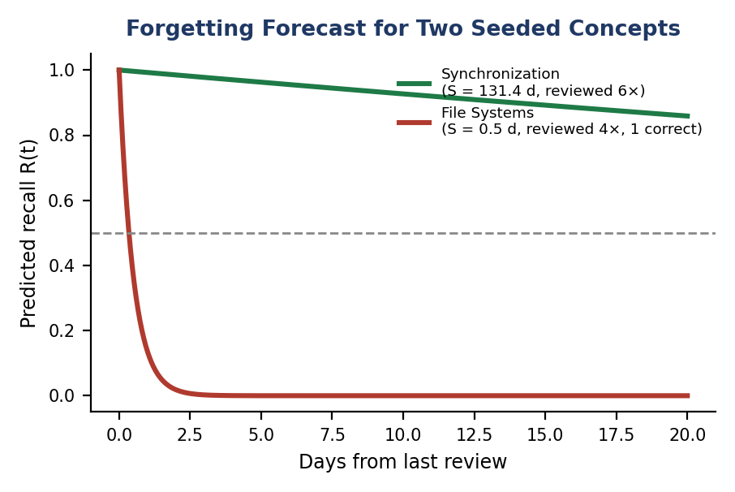
Fig. 7. Real forgetting-curve output for two concepts from the same validation trace, illustrating how strongly review consistency (not just attempt count) drives the memory-stability estimate that the forgetting forecast and learning-outcome predictor both depend on.
XII. DISCUSSION
A. Multi-Agent Architecture Benefits
EduAgent illustrates how a multi-agent architecture with inter-agent collaboration produces a richer learning experience than a single-agent chatbot system. Different learning activities — concept explanation, exercises, self-testing, revision, academic writing — call for different agent behaviours, system prompts, and grading rubrics; a single system prompt cannot simultaneously support Socratic questioning, rubric-based essay grading, adaptive-difficulty oral examination, and the naive-questioner role required for Feynman-technique teach-back.
B. Inter-Agent Collaboration Effectiveness
The inter-agent collaboration strategy — Concept QA identifying weak spots, Exam Predictor skipping mastered areas, and Viva probing weaknesses — is a simple yet effective interaction pattern. Rather than relying on explicit API calls or negotiation protocols between agents, as some multi-agent systems do, EduAgent expresses cross-agent context directly within the LLM prompt, letting the model's own natural-language understanding create inter-agent awareness with minimal engineering overhead.
The Concept QA agent's behaviour illustrates this well: when a student asks about an advanced concept while showing uncertainty about its prerequisites, the PREREQUISITE ALERT mechanism prompts the agent to close the knowledge gap before proceeding — behaviour that would be impossible without weak-point identification feeding into the prompt.
C. Adaptive Learning Integration
Embedding SM-2 spaced repetition directly within the flow of agent interaction produces a markedly more seamless learning experience than a standalone flashcard application, because studying is not a separate activity the student must initiate: flashcard material is generated automatically from the conversation itself, through the same explanation–assessment–scheduling cycle used for concept mastery.
D. Limitations
Several limitations should be noted, several of which were narrowed, though not fully closed, over the course of this revision. (1) The system now supports OpenAI and Anthropic as alternative LLM providers behind a common interface (Section X-E), reducing single-vendor lock-in; Gemini nonetheless remains the default and by far the most thoroughly exercised path, so the alternative providers' behaviour under EduAgent's specific prompts has not yet been evaluated as rigorously. (2) Personalised BKT parameters are now fitted per student via expectation–maximisation once at least eight observations exist (Section VI-F), rather than staying fixed at population defaults indefinitely; the fit is still a single set of parameters pooled across all of a student's concepts within each difficulty tier, rather than fitted per concept, and a new student necessarily starts on the global default until they cross the observation threshold. (3) Real-time collaboration now includes a shared whiteboard and AI-moderated peer debate alongside text chat (Sections VII-D, VII-E), but the whiteboard is intentionally ephemeral (not saved beyond the live session) and collaborative concept-map exploration remains text/chat-only. (4) A rule-based fast path now resolves unambiguous intents without an LLM call (Section IV-A), but ambiguous queries still fall through to LLM-based classification, so a genuinely fine-tuned, dedicated classification model — which would additionally cover the currently-unhandled ambiguous cases — remains future work rather than something this revision completed. (5) The evaluation to date is still substantially qualitative: five pilot users (Section XI-D) and a simulated, code-faithful validation trace (Section XI-E) demonstrate that the platform's adaptive mechanisms compute correctly and converge to sensible, explainable state, but neither substitutes for the statistically powered, human-subjects study of actual learning-outcome gains described in Sections XI-A–C, which has not yet been conducted. (6) The Multi-Agent Debate mode, including its new peer-debate variant, still uses a single LLM backend and a single sampling temperature per persona; using different models or temperatures per persona to increase the diversity of perspective remains unexplored. (7) The hallucination-mitigation check introduced in Section X-E is a lexical/retrieval-score heuristic, not a fact-checker — it is designed to catch gross ungrounded-confidence failures (and, as reported in Section X-E, it did catch a real prompt-leakage defect during development) but cannot verify the correctness of specific claims within an otherwise well-grounded answer.
E. Future Work
With the items from the previous revision of this work now implemented (Sections VI-F, VI-G, VII-D, VII-E, VII-F, and X-E), the following directions remain open. (1) Training or fine-tuning a dedicated, lightweight classification model for intent recognition, to replace LLM-based classification on the ambiguous queries the current rule-based fast path cannot resolve. (2) A longitudinal study tracking grade improvement across a full semester, building on the user-study protocol of Sections XI-A–C and using the simulated validation trace of Section XI-E only as a pre-registered sanity check on the pipeline, not as evidence of the study's outcome. (3) Systematic evaluation of the OpenAI and Anthropic provider paths under EduAgent's own prompts and rubrics, rather than relying on Gemini-path results to stand in for all three. (4) Extending per-student BKT fitting from per-difficulty-tier pooling to per-concept parameter estimation, once individual concepts accumulate enough observations to support it. (5) Persisting whiteboard sessions (currently ephemeral by design, Section VII-D) as an opt-in, reviewable artifact for students who want to revisit a worked example. (6) Retaining a transcript and instructor-facing analytics for peer-debate sessions (currently ephemeral per room, Section VII-E), so that argumentation quality can be tracked over time the way concept mastery already is. (7) Strengthening the hallucination-mitigation mechanism of Section X-E from a lexical/retrieval-score heuristic toward claim-level citation verification against the retrieved source material.
XIII. CONCLUSION
This paper presented EduAgent, an AI-based educational platform that moves beyond a single chatbot to offer six specialised agents operating in inter-agent cooperation over a shared knowledge layer. The platform implements the SM-2 spaced-repetition algorithm with auto-generated flashcards, Bayesian Knowledge Tracing — now with per-student parameters fitted via expectation–maximisation — with predictive forgetting and a learning-outcome predictor built on it, a Multi-Agent Debate and Consensus mode extended with an AI-moderated peer-debate variant, a per-student Learning Genome that now also reflects peer-collaboration behaviour, a Zone-of-Proximal-Development-based Knowledge Frontier, AI-driven study planning, voice-enabled oral-examination simulation, multimodal image understanding, collaborative learning spaces including a live shared whiteboard and persisted material annotation, custom agent creation, comprehensive analytics, a provider-agnostic LLM abstraction layer, and explicit hallucination-mitigation grounding on every fact-answering agent.
The contributions of this work include a practical multi-agent educational architecture with prompt-level inter-agent cooperation; a BKT engine with Ebbinghaus-based predictive forgetting and per-student EM-fitted parameters that forecasts per-concept memory decay and future assessment readiness; a debate mode, now available in both AI-only and AI-moderated peer variants, enabling calibrated, multi-perspective answers; a behavioural Learning Genome, extended with social-learning signals, that personalises every agent's response; a Zone-of-Proximal-Development-based Knowledge Frontier that recommends the most appropriate next concept; the integration of spaced-repetition scheduling directly into a conversational AI workflow; voice and multimodal interaction modes; real-time collaborative learning with a shared AI assistant, live whiteboard, and peer debate; a no-code framework for professor-defined assessment agents; and a provider-agnostic, hallucination-mitigated LLM layer. Beyond the qualitative pilot evidence reported previously, this revision additionally reports a fully reproducible, code-faithful simulated validation trace (Section XI-E) demonstrating that these mechanisms compute correctly and converge to internally consistent, explainable state — evidence of a correctly functioning adaptive pipeline, presented honestly as validation rather than as a substitute for the human-subjects efficacy study that remains future work.
EduAgent is implemented as a production-ready, full-stack application with more than 130 automated tests, a five-service Docker deployment, multi-stage production Dockerfiles, and accompanying documentation, deployment guides, demo and validation seed scripts, and a user-study protocol. By combining established theoretical learning models — BKT, the Ebbinghaus forgetting curve, and Vygotsky's ZPD — with multi-agent AI, real-time collaboration, hallucination-aware generation, and analytics, this work demonstrates the potential of an AI-based educational platform that adapts to each student's individual needs while giving educators actionable insight into their class.
EduAgent thus represents a concrete step toward personalised, adaptive, and collaborative AI-supported education.
REFERENCES
[1] Khan Academy, “Khanmigo: AI for Education,” 2023.
[2] Duolingo, “Duolingo Max with GPT-4,” 2023.
[3] Carnegie Learning, “MATHia Adaptive Math Platform,” 2023.
[4] S. Hong et al., “MetaGPT: Meta Programming for Multi-Agent Collaborative Framework,” arXiv:2308.00352, 2023.
[5] Q. Wu et al., “AutoGen: Enabling Next-Gen LLM Applications via Multi-Agent Conversation,” arXiv:2308.08155, 2023.
[6] P. Wozniak, “Application of a computer to improve the results obtained in working with the SuperMemo method,” 1990.
[7] P. Lewis et al., “Retrieval-Augmented Generation for Knowledge-Intensive NLP Tasks,” Proc. NeurIPS, 2020.
[8] LangChain, “LangGraph: Build stateful multi-actor applications with LLMs,” 2024.
[9] OpenAI, “GPT-4 Technical Report,” arXiv:2303.08774, 2023.
[10] Google, “Gemini: A Family of Highly Capable Multimodal Models,” arXiv:2312.11805, 2023.
[11] J. R. Carbonell, “AI in CAI: An Artificial Intelligence Approach to Computer-Assisted Instruction,” IEEE Trans. Man-Machine Systems, 1970.
[12] A. Collins, “Processes in Acquiring Knowledge,” in Schooling and the Acquisition of Knowledge, 1977.
[13] G. Li et al., “CAMEL: Communicative Agents for Mind Exploration of Large Language Model Society,” arXiv:2303.17760, 2023.
[14] J. S. Park et al., “Generative Agents: Interactive Simulacra of Human Behavior,” arXiv:2304.03442, 2023.
[15] LangChain, “LangChain: Building applications with LLMs through composability,” 2023.
[16] H. Ebbinghaus, Memory: A Contribution to Experimental Psychology, 1885.
[17] J. Brooke, “SUS: A Quick and Dirty Usability Scale,” in Usability Evaluation in Industry, 1996.
[18] A. Vaswani et al., “Attention Is All You Need,” Proc. NeurIPS, 2017.
[19] J. Devlin, M.-W. Chang, K. Lee, and K. Toutanova, “BERT: Pre-training of Deep Bidirectional Transformers for Language Understanding,” in Proc. NAACL, 2019.
[20] T. Brown et al., “Language Models are Few-Shot Learners,” Proc. NeurIPS, 2020.
[21] A. T. Corbett and J. R. Anderson, “Knowledge Tracing: Modeling the Acquisition of Procedural Knowledge,” User Modeling and User-Adapted Interaction, vol. 4, pp. 253–278, 1994.
[22] L. S. Vygotsky, Mind in Society: The Development of Higher Psychological Processes. Cambridge, MA: Harvard University Press, 1978.
[23] C. Piech et al., “Deep Knowledge Tracing,” Proc. NeurIPS, 2015.
[24] L. R. Rabiner, “A tutorial on hidden Markov models and selected applications in speech recognition,” Proc. IEEE, vol. 77, no. 2, pp. 257–286, 1989.

